AI-Based Software Release Risk Predictor (RRP)

Recommended architecture and data collection strategy
Your project will analyze a GitHub repository and help developers assess whether a proposed software release has warning signs that deserve attention before deployment.
The most important design decision is this: your system must collect evidence about a repository, and your ML model must learn from historical examples that match the prediction it is expected to make. We should not train on an unrelated dataset and claim it can reliably predict the risk of any software release.
I'll design this as a practical, laptop-friendly Software Engineering project using Python, Git, GitHub, machine learning and automated quality checks.

1. What the finished application will do
Input: A GitHub repository
The user provides a public repository URL or connects a private repository with appropriate authorization.
Analysis: Inspect the code and development history
The system calculates code metrics, checks recent commits, examines test results and reviews available defect history.
Prediction: Estimate release risk
A trained model estimates defect risk when the repository data matches the model's training scope. Other checks remain available even when an ML prediction is unsupported.
Output: A release-readiness report
The report shows passed checks, failed tests, warning signs, risk estimates where justified, and recommended next actions.
For the first version, I recommend supporting Git repositories containing Python projects. You can add JavaScript and other languages after the core pipeline works.

2. Architecture: the components you will build

flowchart TD
A[GitHub Repository URL] --> B[Repository Connector]
B --> C[Code and History Analyzer]
B --> D[Test and CI Result Collector]
B --> E[Bug and Issue History Collector]
C --> F[Feature Engineering]
D --> F
E --> G[Historical Label Builder]
F --> H[Risk Assessment Engine]
G --> I[ML Training Pipeline]
I --> H
H --> J[Quality Gates]
J --> K[Release Risk Dashboard]
J --> L[Validation and Audit Report]

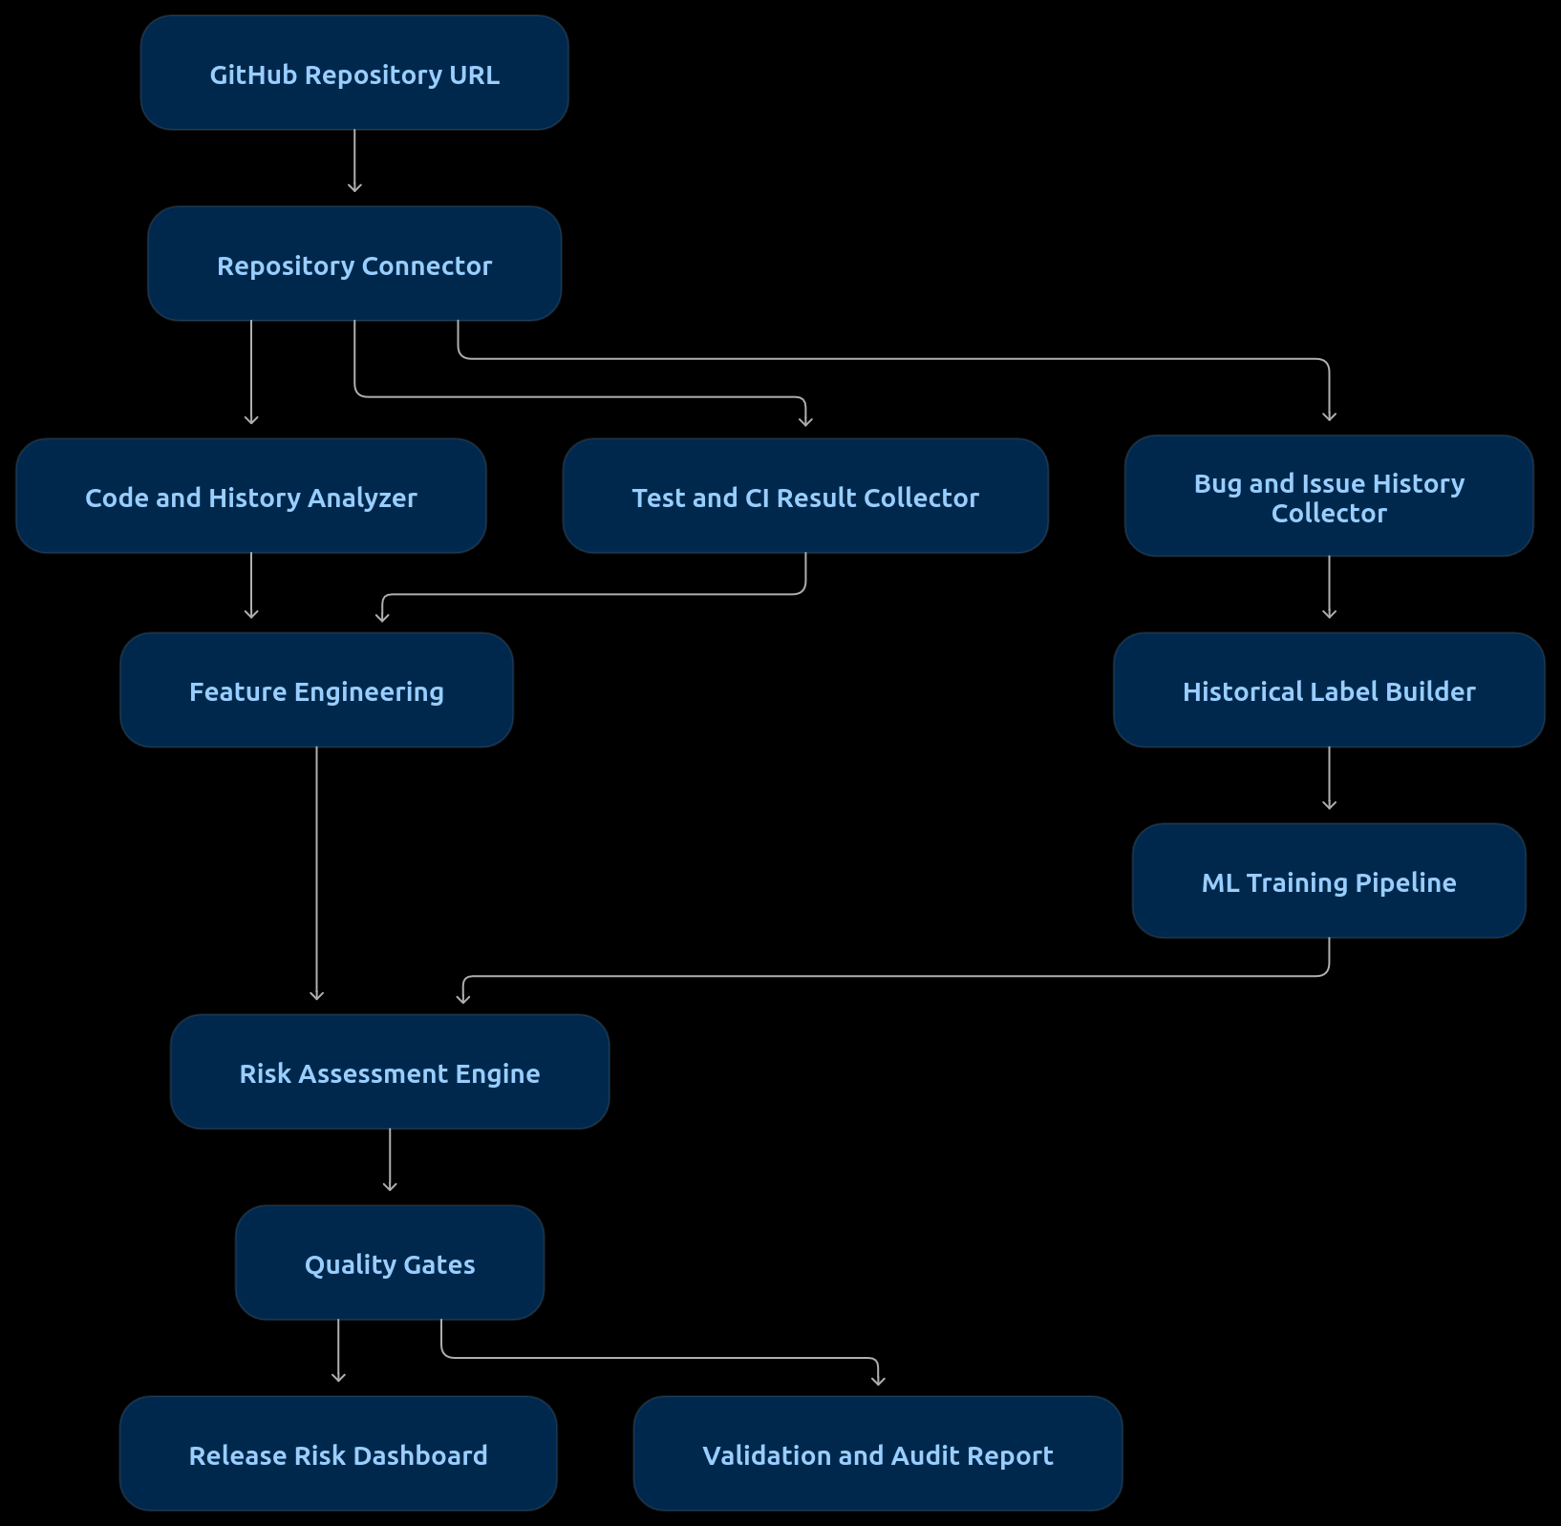
The application has two related workflows:
- Training workflow: Uses historical examples with known outcomes to train and evaluate the model.
- Assessment workflow: Inspects a new repository or proposed release and uses available evidence to assess its risk.
Do not train the model every time someone submits a repository. Train and validate it separately, version the model, and then use that approved version for assessments.

Recommended technology stack
Component | Technology
Repository access | Git CLI and GitHub REST API
Code metrics | Radon for Python complexity and code metrics
Test execution | pytest, with isolated execution
CI results | GitHub Actions and Checks API
Data processing | pandas, NumPy
ML model | scikit-learn
Model storage | joblib plus version metadata
Dashboard | Streamlit
Automated verification | pytest
Experiment tracking | CSV/JSON initially; MLflow later
GitHub provides APIs for repository issues, pull requests, commits and check results. These can supply the evidence your system needs.
GitHub Docs
+3

3. Data collection: what you should collect and why
Your dataset should have two main layers.

Layer A: Historical training dataset
This teaches the ML model which software characteristics are associated with future defects.
The ideal training example is a particular commit, pull request or release, with:
- Information available before the release.
- A documented prediction target.
- Evidence of defects discovered afterward.
- A timestamp that allows you to distinguish earlier information from later outcomes.
For example:
Before-release information | Outcome observed later
Number of changed files | Defect discovered after release
Lines added and deleted | Post-release bug report linked to the change
Code complexity | Whether a defect was subsequently recorded
Previous defect history | Number of linked post-release defects
Test failures before release | Whether the release had a documented defect
These are proposed fields, not a ready-made dataset. You must collect them and verify their labels.

Layer B: Current repository assessment data
When a user submits a repository, collect whatever evidence is available:
- Source-code metrics.
- Recent commits and changed files.
- Test results from the current commit.
- CI check status.
- Historical issues labeled as bugs.
- Previous release and defect history, where available.
A repository with no tests or no issue history should still receive a report, but the application should explicitly say that some evidence is unavailable. Missing information is not proof that the software is safe.

4. Where to collect the historical data
I recommend three sources, in this order.
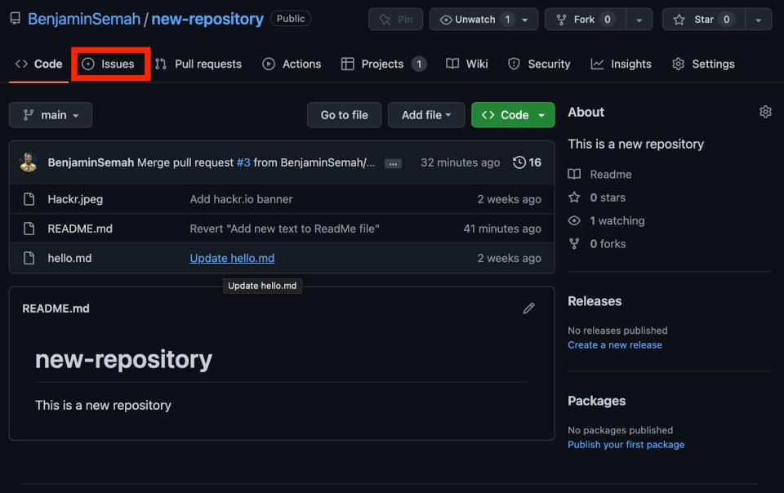
Source 1 — Public GitHub repositories
Primary source
Collect commit history, pull requests, bug issues and available CI results. GitHub's REST API supports retrieving these records.
GitHub Docs
+2
Start with approximately 10–30 carefully selected Python repositories for a manageable prototype. This is a collection target, not a guarantee that they will contain enough usable labeled examples.
GitHub REST API documentation
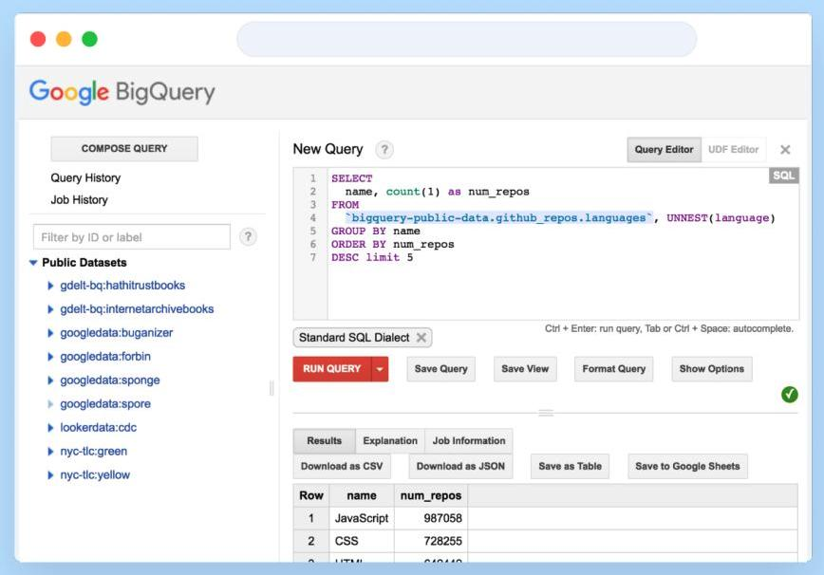
Source 2 — Public research datasets
Use existing software defect datasets to establish a baseline, understand code metrics, and compare your model with published approaches. Google also documents how to access public datasets through BigQuery.
Google Cloud Documentation
NASA PROMISE/KC1 can be useful for module-level experiments, but it should not be treated as ground truth for release-level GitHub predictions.
NASA PROMISE dataset repository
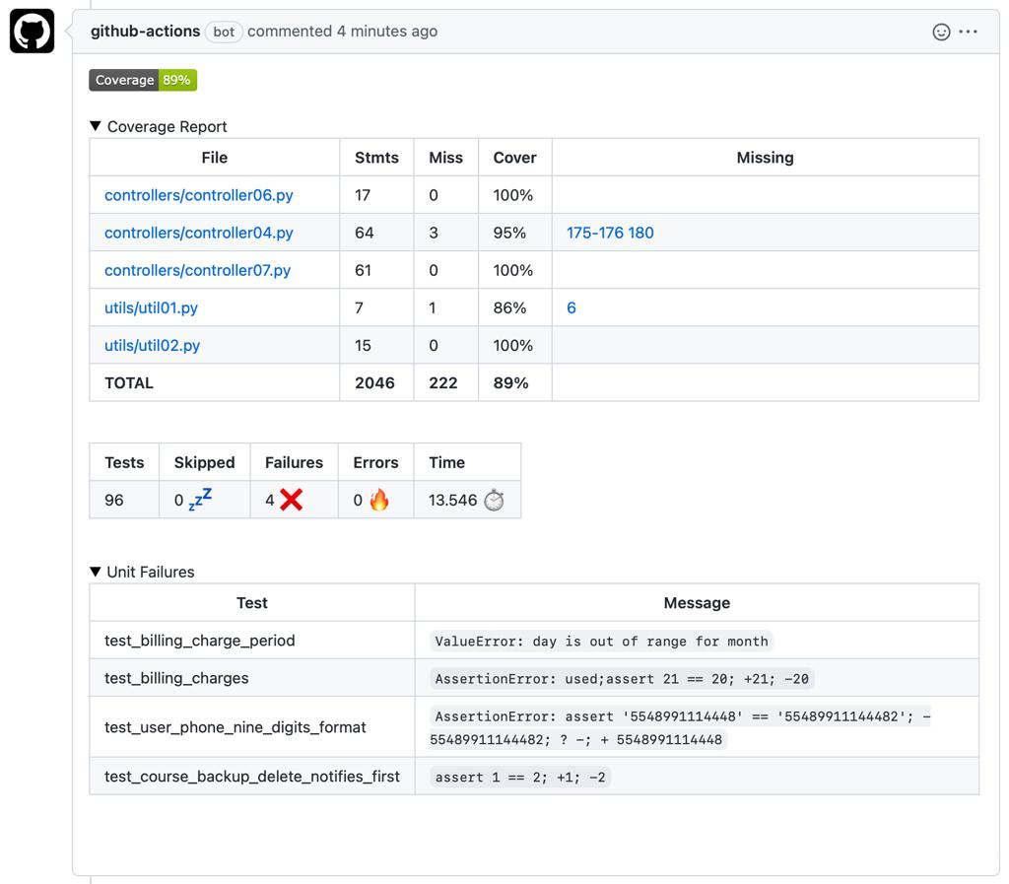
Source 3 — Test and CI histories
Collect test outcomes for individual commits from repositories that publish continuous-integration results. GitHub's Checks API can provide check-run information where available.
GitHub v3 REST API (ghes)
+1
These records help you measure test status and assess current release readiness. They are not, by themselves, proof that a release contained a real-world defect.

The most important data-labeling problem
A GitHub issue labeled bug does not automatically tell you which release introduced the defect. Likewise, a commit message saying "fix bug" does not prove that the preceding release failed.
For trustworthy labels, use documented links between defects and code changes, bug-fix commits, issue references, and the relevant time period. Exclude ambiguous examples or label them as uncertain.
For a first prototype, it is acceptable to start with a smaller dataset that has carefully verified labels rather than thousands of poorly labeled records.

5. How to define the prediction target
Before training any model, decide exactly what it predicts.
I recommend starting with this target:
Will a proposed change or release have at least one documented defect linked to it within a defined follow-up period?
For example, you might use a 30-day follow-up window if the selected repositories have enough history. The window is a research choice, not a universal standard.
Define the label as:
- 1 — at least one qualifying defect is linked to the change during the follow-up period.
- 0 — no qualifying defect is observed during that period and the history is sufficiently complete.
- unknown — insufficient history or ambiguous defect attribution.
Do not automatically treat every release with no recorded bug as a confirmed clean release. It may simply have incomplete issue tracking.
Also, only use features available at prediction time. A bug report discovered 20 days after a release cannot be an input for predicting that same release.

6. Build two separate assessment mechanisms
This distinction will make your project stronger.

Mechanism A: Evidence-based quality checks
These can work on a user's repository immediately.
- Did the available test suite pass?
- Are required CI checks failing?
- Are there unusually large code changes?
- Are required test reports missing?
- Does the project have unusually complex or recently changed code?
These checks produce observable findings. For example, "3 CI checks failed" is evidence, not an ML prediction.

Mechanism B: ML-based defect-risk prediction
This uses historical examples to estimate whether the proposed change resembles changes associated with defects.
- Train the model on historical data.
- Validate it on later examples and preferably unseen repositories.
- Check calibration and performance across projects.
- Produce a prediction only when the model's training scope matches the target sufficiently.
If the data is insufficient or the repository is outside the model's validated scope, show "ML risk estimate unavailable" instead of inventing a score.
The two mechanisms complement each other. A release can fail a required test even if the ML model estimates low defect risk.

7. Model training and validation strategy
Start with a simple baseline rather than a complex neural network.
First models:
- Logistic Regression.
- Random Forest.
Useful evaluation metrics:
Metric | Why it matters
Precision | How often a predicted risky change actually has the target defect outcome
Recall | How many changes with documented defects the model identifies
F1-score | Balances precision and recall
PR-AUC | Useful when defect-positive examples are uncommon
Calibration | Checks whether predicted probabilities match observed frequencies
Use a chronological split: train on earlier changes, validate on a later period, and keep a final test period untouched until evaluation. Also report performance on repositories not used for training, where data volume permits.
This matters because a model can appear accurate simply by memorizing repository-specific patterns or by accidentally seeing future information.

8. Release quality gates
Your project title emphasizes Verification and Validation, so you should have quality gates for both the software release being assessed and the ML model itself.
Gate | Example rule
Input gate | Repository is accessible and contains supported source files
Test gate | Required tests must pass or be explicitly waived
Data gate | Required inputs and labels meet validation rules
ML performance gate | Model meets predefined recall and precision requirements on validation data
Regression gate | New model does not exceed an acceptable performance regression
Applicability gate | Model is used only within its validated scope
Do not choose arbitrary ML thresholds simply to make the system pass. Document why each threshold was selected and evaluate the trade-off between missing defects and generating too many warnings.
The dashboard should distinguish a quality-gate failure from a high ML-predicted risk. One is a defined rule; the other is an estimate.

9. Suggested project structure
software-rrp/
├── data/
│ ├── raw/
│ ├── processed/
│ └── dataset_card.md
├── src/
│ ├── github_connector.py
│ ├── git_analyzer.py
│ ├── code_metrics.py
│ ├── ci_collector.py
│ ├── defect_labeling.py
│ ├── preprocessing.py
│ ├── train.py
│ ├── evaluate.py
│ ├── predict.py
│ └── quality_gates.py
├── models/
├── reports/
├── tests/
├── app.py
├── requirements.txt
└── README.md
dataset_card.md should explain where the data came from, how labels were generated, what information is missing, and what kinds of repositories the model has been evaluated on.

10. A realistic implementation roadmap
Week 1
Repository analysis
Accept a GitHub URL, clone or fetch the repository safely, identify Python files, calculate code metrics and display basic repository information.
Week 2
Historical data and labels
Select repositories, collect commits and bug history, define a defensible labeling method and build a dataset.
Week 3
Model training and validation
Train baseline models, compare performance, test chronological generalization and document limitations.
Week 4
Dashboard and V&V tests
Add test-result collection, quality gates, risk reporting, model version comparison and final automated tests.
Four weeks is an initial target for a working prototype, not a guarantee that the historical dataset will be large or reliable enough for a general-purpose predictor. Data labeling may require additional time.

11. What the final demonstration should prove
At your project presentation, you should be able to demonstrate all of the following:
- A user submits a GitHub repository URL.
- Your application analyzes supported code and displays metrics.
- It collects available CI and test results.
- It reports concrete failures and missing evidence.
- It produces an ML risk estimate only if the model is applicable.
- It explains the prediction's main contributing factors.
- It shows model evaluation results, quality gates and limitations.
- It compares model versions and identifies performance regressions.
That is a strong Software V&V project because you are not merely training a classifier: you are building a complete pipeline that verifies its inputs, evaluates the model and controls how predictions are used.
The best next step is to build the repository analyzer first. Once it can reliably inspect a Python GitHub project and collect code metrics, you can develop the historical data pipeline and ML model around the information your application actually has available.

Detail plan: AI-Based Software Release Risk Predictor (RRP)

Step-by-step construction guide
We'll build this project in stages on your Linux Mint laptop using Python. By the end, you should have a working application where someone enters a GitHub repository URL, your system analyzes its source code and available test results, and a dashboard reports release risks with supporting evidence.
One important rule throughout construction: the system must distinguish actual findings from predicted risks. For example, a failed test is an observed finding; a model's prediction that a future defect may occur is an estimate that must be validated.

What we're going to build
GitHub Repository URL
Public repository for the initial version
Repository Analyzer
Git history, Python files, complexity and code changes
Test and Evidence Collector
Existing CI results, test reports and available defect history
Risk Assessment Engine
Evidence-based rules + validated ML prediction when supported
Streamlit Dashboard
Findings, risk indicators, quality gates and reports

Construction roadmap
Build in this order. Do not start with the ML model or dashboard before the data collection works.

01
Set up the development environment
Python, virtual environment, Git and dependencies

02
Build the GitHub repository analyzer
Accept a URL, validate it and inspect the repository

03
Calculate source-code metrics
Measure size, complexity and recent changes

04
Collect test and CI evidence
Find available test results and report failures

05
Build the historical dataset
Collect historical changes and carefully define defect labels

06
Train and validate ML models
Compare baseline models and check generalization

07
Implement release quality gates
Apply explicit rules and separate them from ML predictions

08
Build the Streamlit dashboard
Create a usable interface and reports

09
Test, document and demonstrate
Run verification tests and prepare your evaluation report

Phase 1 — Set up your development environment
We'll use your Linux Mint system, Python, VS Code and the terminal.

Step 1. Create the project folder
Open your terminal and run:
mkdir -p ~/projects/software-rrp
cd ~/projects/software-rrp

mkdir -p src data/raw data/processed models reports tests
code .
Your project will live in ~/projects/software-rrp.

Step 2. Create a Python virtual environment
python3 --version
python3 -m venv .venv
source .venv/bin/activate
python -m pip install --upgrade pip
If creating the environment fails because of missing system packages, install the virtual-environment package:
sudo apt update
sudo apt install python3-venv git
Then recreate the environment if necessary.

Step 3. Install the initial libraries
Create a file named requirements.txt containing:

streamlit
pandas
numpy
scikit-learn
radon
requests
python-dotenv
joblib
pytest

Install them:
pip install -r requirements.txt
We'll add more dependencies only when needed. This keeps the first version manageable.

Step 4. Create the initial file structure
software-rrp/
├── .venv/
├── src/
│ ├── github_connector.py
│ ├── git_analyzer.py
│ ├── code_metrics.py
│ ├── ci_collector.py
│ ├── preprocessing.py
│ ├── train.py
│ ├── evaluate.py
│ ├── predict.py
│ └── quality_gates.py
├── data/
│ ├── raw/
│ └── processed/
├── models/
├── reports/
├── tests/
├── app.py
├── requirements.txt
├── .gitignore
└── README.md
Create a .gitignore file:

.venv/
__pycache__/
*.pyc
.env
.env.*
!.env.example
data/raw/
data/processed/
models/*.joblib
.pytest_cache/

This prevents virtual-environment files, credentials and generated datasets or models from being committed accidentally. If you later choose to version specific model artifacts, handle that deliberately.

Phase 2 — Build the GitHub repository analyzer
This is the first real feature of your project.

Step 5. Decide what the user can submit
For version 1, accept a public GitHub repository URL, such as:
https://github.com/psf/requests
The user should not need to upload a ZIP file or install your software in their own repository.
Your application will:
- Validate the URL.
- Identify the owner and repository.
- Retrieve the source code or clone the repository.
- Analyze supported files.
- Produce a structured report.
Initially, accept only canonical public GitHub repository URLs. Later, you can add private repository authorization through GitHub's supported authentication mechanisms.

Step 6. Build the GitHub connector
Create src/github_connector.py.
The first implementation should validate the URL and retrieve repository metadata through GitHub's API.
import reimport requestsGITHUB_API = "https://api.github.com"def parse_github_url(url: str) -> tuple[str, str]: """Extract owner and repository from a canonical GitHub URL.""" pattern = ( r"^https://github\.com/" r"([A-Za-z0-9_.-]+)/" r"([A-Za-z0-9_.-]+)/?$" ) match = re.fullmatch(pattern, url.strip()) if not match: raise ValueError( "Enter a canonical GitHub repository URL." ) owner, repo = match.groups() if repo.endswith(".git"): repo = repo[:-4] if not owner or not repo: raise ValueError("Invalid repository URL.") return owner, repodef get_repository_info(owner: str, repo: str) -> dict:
Run it:
python src/github_connector.py
You should see repository metadata printed in your terminal, assuming the repository is accessible and the network request succeeds.
The metadata tells you what repository you are inspecting. It does not tell you whether the software is safe to release.

Step 7. Add verification tests
Create tests/test_github_connector.py.
import pytestfrom src.github_connector import parse_github_urldef test_valid_repository_url(): assert parse_github_url( "https://github.com/psf/requests" ) == ("psf", "requests")def test_trailing_slash(): assert parse_github_url( "https://github.com/psf/requests/" ) == ("psf", "requests")def test_rejects_other_hosts(): with pytest.raises(ValueError): parse_github_url( "https://example.com/user/repo" )def test_rejects_extra_path(): with pytest.raises(ValueError): parse_github_url( "https://github.com/user/repo/tree/main" )def test_rejects_empty_repository(): with pytest.raises(ValueError): parse_github_url("https://github.com/user/")
Add an empty src/__init__.py file so Python can import the module, then run:
pytest -q
Milestone 1: Your project can validate a repository URL, fetch its metadata and test the URL validation logic.

Phase 3 — Retrieve source code and calculate metrics

Step 8. Download the repository safely
For the prototype, you can use Git to retrieve public repositories. Avoid running arbitrary repository code while analyzing it.
Before cloning, enforce limits such as:
- Maximum repository size.
- Maximum number of files.
- Maximum analysis time.
- Allowed file types.
- No submodules or Git LFS downloads in the initial version.
Use a dedicated temporary directory and a restricted process for cloning. Do not run setup.py, installation scripts, build scripts or test commands from untrusted repositories on your normal laptop.
For the first version, downloading a source archive through GitHub's API can be simpler than a full clone. Later, Git history analysis will require Git commit data.

Step 9. Analyze the Git history
Create src/git_analyzer.py.
Use Git commands to collect information such as:
- Latest commit hash.
- Commit date.
- Number of commits in a chosen time window.
- Files changed in the latest commit.
- Lines added and deleted.
- Recent change frequency.
For example, after retrieving a repository into a controlled local directory:
git -C /path/to/repository log -1 --format=%H
git -C /path/to/repository log -1 --format=%cI
git -C /path/to/repository show --stat --oneline HEAD
These are examples of the commands your Python program can execute with subprocess.run, using an argument list rather than constructing a shell command from user input.
You should record the analyzed commit hash in every report. Otherwise, the repository might change between analysis and reporting, making results difficult to reproduce.

Step 10. Calculate code metrics
Create src/code_metrics.py.
Start with Python source files. Use Radon to calculate:
- Lines of code.
- Cyclomatic complexity.
- Maintainability index.
- Number of functions and classes.
For example, this small function can analyze Python files inside a directory:
from pathlib import Pathfrom radon.complexity import cc_visitfrom radon.metrics import mi_visitfrom radon.raw import analyzedef analyze_python_file(file_path: Path) -> dict: source = file_path.read_text( encoding="utf-8", errors="replace", ) raw = analyze(source) blocks = cc_visit(source) return { "file": file_path.name, "loc": raw.loc, "lloc": raw.lloc, "sloc": raw.sloc, "comments": raw.comments, "complexity": sum( block.complexity for block in blocks ), "function_count": sum( block.__class__.__name__ == "Function" for block in blocks ), "class_count": sum( block.__class__.__name__ == "Class" for block in blocks ), "maintainability_index": mi_visit(source, multi=True), }def analyze_directory(directory: str) -> list[dict]: root = Path(directory) results = [] for path in root.rglob("*.py"): if any( part in {".git", ".venv", "venv", "__pycache__"} for part in path.parts ): continue try: results.append(analyze_python_file(path)) except (OSError, UnicodeError, SyntaxError) as exc: results.append({ "file": path.name, "error": str(exc), }) return results
This is a starting point. Before using it on untrusted repositories, add file-count and file-size limits, symlink protections, and stronger error handling.
Also, maintainability and complexity metrics are indicators, not proof of defects. Their meaning must be assessed empirically.

Step 11. Save the metrics
Convert the results into a pandas DataFrame and save them as JSON or CSV under data/processed/ for development.
Your eventual analysis record should include at least:
Field | Example
Repository | psf/requests
Commit hash | Exact analyzed commit
Analysis timestamp | When your program ran
Language | Python
Files analyzed | Number of supported files
Total lines | Aggregate code size
Average complexity | Aggregate complexity indicator
High-complexity files | Count based on a documented threshold
Do not label a repository "high defect risk" simply because it has many lines or complex code. These are features to evaluate, not validated risk thresholds.
Milestone 2: Your application can inspect a Python repository and produce reproducible code metrics.

Phase 4 — Collect test results and defect evidence
This phase makes your RRP more useful than a tool that only measures code complexity.

Step 12. Collect test and CI results
Create src/ci_collector.py.
Your system should first look for existing evidence, rather than immediately trying to execute a repository's code.
Collect the following where available:
Evidence | Source
CI job status | GitHub Actions
Test pass/fail status | Test reports or workflow artifacts
Test coverage | Coverage report, if published
Static-analysis results | Existing linter or scanner reports
Build status | CI workflow result
Use the GitHub REST API to inspect workflow runs and check runs associated with the commit being assessed.
Official documentation:
- GitHub Actions workflow runs API
- GitHub check runs API
A workflow run that passed does not necessarily mean every test passed or that the software has no bugs. Record the actual evidence and its limitations.
If no CI results are available, return an explicit status such as unavailable, not passed.

Step 13. Add optional local test execution
In a later iteration, allow the user to run the project's tests inside an isolated environment.
For Python projects, your system can recognize a supported test suite and collect:
- Number of tests passed.
- Number of tests failed.
- Number of errors.
- Test duration.
- Coverage, if available.
However, running arbitrary code from GitHub is risky. A virtual environment alone is not a security sandbox. Use an isolated container or disposable environment with no secrets, restricted network access, CPU and memory limits, and a timeout.
For your first version, importing existing CI results is safer and easier than running arbitrary projects.

Step 14. Collect bug history
Use the GitHub Issues API to identify issues that are explicitly labeled as bugs and have a relationship to the relevant code change.
Documentation: GitHub Issues API
Store fields such as:
- Issue number.
- Issue labels.
- Opened and closed timestamps.
- Referenced commits or pull requests.
- Whether a fix can be linked to the issue.
- Whether the issue was discovered before or after the target release.
Do not use the number of open issues as a direct defect count. Many issues are feature requests, duplicates, questions or bugs unrelated to the release being assessed.
Milestone 3: Your system can report code metrics and whatever test and defect evidence is available for a repository.

Phase 5 — Build your own historical training dataset
This is the most research-intensive part of the project.
Your training dataset needs historical examples that connect information available before a change was released with defects discovered afterward.

Step 15. Choose a unit of prediction
Use a specific unit consistently. I recommend a commit or pull request that is merged into the main branch.
For each example, record:
Column | Meaning
repo_id | Repository identifier
commit_sha | Exact commit being assessed
commit_date | Date of the change
files_changed | Number of files changed
lines_added | Lines added
lines_deleted | Lines deleted
complexity_before | Complexity measured before the change
previous_defects | Relevant defect history available at that time
tests_failed_before_release | Test failures known before release
defect_within_30_days | Target label, when reliably established
label_status | Confirmed, negative with sufficient observation, or unknown
These are proposed fields for your own data collection, not columns that all exist in GitHub by default.
For example, complexity_before should be calculated from the code snapshot before the target change if you are using it to predict risk before that change. A metric calculated from the final code may be valid for a different prediction time, but you must define that timing consistently.

Step 16. Define your defect-labeling rules
Write a small specification before collecting thousands of records.
A possible rule is:
- Positive (1): A defect is linked to the target change or release, and the evidence supports discovery within the 30-day follow-up window.
- Negative (0): The follow-up period is complete, the repository's issue history is sufficiently observable, and no qualifying defect is recorded.
- Unknown: Attribution is ambiguous, history is incomplete, or the follow-up period has not elapsed.
Thirty days is a starting research choice. You can choose another window if your dataset and supervisor justify it.
You must also avoid a common mistake called label leakage. If you use the future bug report, the eventual fix commit, or post-release test results as model inputs, the model may appear excellent during testing but fail when making real predictions.

Step 17. Collect a manageable pilot dataset
Start with a small pilot of around 10–30 Python repositories. Prefer repositories with:
- A meaningful commit history.
- Consistent bug labels.
- Public pull requests and issue references.
- CI workflows or published test results.
- Sufficient history for your chosen follow-up window.
The number of repositories is only a starting collection target. It does not guarantee that you will have enough correctly labeled examples to train a useful model.
Build a collector that saves records as JSONL or CSV. Keep a manifest containing the source URL, collection timestamp, commit hash, label rule and any missing data.
If the pilot produces too few trustworthy examples, expand the collection or use a research dataset that better matches the target. Do not silently convert uncertain records into negative examples.

Step 18. Use KC1 only for the experiment it supports
You can use KC1 to experiment with software-module defect prediction and learn how to build an ML pipeline.
But do not combine KC1's module-level defect labels with your repository-level release labels as if they were equivalent. They describe different prediction targets.
Your final release-risk model should be trained and evaluated using data that actually supports the release or change-level claim.
Milestone 4: You have a documented dataset with historical examples, traceable labels and a clearly defined prediction target.

Phase 6 — Train and validate the ML model

Step 19. Prepare your features
Create src/preprocessing.py.
Separate the data into:
- Features (X): Metrics available at the time the risk prediction is made.
- Target (y): Whether the defined defect outcome occurred afterward.
Exclude identifiers, post-release information, future bug-fix details and fields that directly encode the target.
Handle missing values and categorical variables using a scikit-learn pipeline. Fit preprocessing only on training data.

Step 20. Train two baseline models
Create src/train.py.
Begin with:
- Logistic Regression — a simple, interpretable baseline.
- Random Forest — a model capable of learning nonlinear relationships.
Use a chronological split for training and testing. Ideally, also evaluate on repositories that were not used in training.
A minimal training structure looks like this:
import pandas as pdfrom sklearn.compose import make_column_transformerfrom sklearn.impute import SimpleImputerfrom sklearn.linear_model import LogisticRegressionfrom sklearn.pipeline import make_pipelinefrom sklearn.preprocessing import StandardScalerfrom sklearn.metrics import ( classification_report, confusion_matrix,)def train_baseline( train_csv: str, test_csv: str, target_column: str,): train = pd.read_csv(train_csv) test = pd.read_csv(test_csv) X_train = train.drop(columns=[target_column]) y_train = train[target_column] X_test = test.drop(columns=[target_column]) y_test = test[target_column] numeric_columns = X_train.select_dtypes( include="number" ).columns.tolist() preprocess = make_pipeline( SimpleImputer(strategy="median"), StandardScaler(), )
This is a training template, not a complete production trainer. Before running it, you must ensure that the CSVs contain only permitted feature columns, that the split is chronologically correct, and that both classes are represented where required.
Also, do not select the final model using the same test set you use to report final performance. Use training and validation data for model selection, then evaluate once on an untouched test set.

Step 21. Measure model performance
Use these metrics:
- Precision: How many predicted defect cases actually met your defect definition?
- Recall: How many cases with the target defect did your model detect?
- F1-score: A balance between precision and recall.
- PR-AUC: How well the model distinguishes positive cases when defects are relatively uncommon.
- Calibration: Whether predicted probabilities agree with observed frequencies.
Choose thresholds based on validation evidence and the cost of missed defects versus unnecessary warnings.
If the model has not been calibrated and validated, display a predicted class or experimental score without pretending that it is a reliable probability of failure.

Step 22. Add explainability
For each prediction, show the factors that influenced the model, where the chosen model supports meaningful explanations.
For example:
- A large number of recent changes.
- Higher-than-usual complexity.
- A history of related defects.
- Available test failures.
Distinguish model-derived explanations from actual observed findings. An explanation is not proof that a feature caused a defect.
Milestone 5: You have an ML model, an evaluation report and documented evidence about where the model does and does not generalize.

Phase 7 — Implement the release quality gates
Now create src/quality_gates.py.
A quality gate is a rule that determines whether the assessed release meets a required condition.
Start with explicit rules. Keep them separate from ML predictions.

Step 23. Create the initial quality-gate engine
def evaluate_quality_gates( test_status: str, ci_status: str, analysis_complete: bool, model_validated: bool, predicted_risk: float | None = None, risk_threshold: float = 0.70,) -> dict: findings = [] if not analysis_complete: findings.append({ "gate": "Analysis completeness", "status": "BLOCKED", "reason": "Required analysis is incomplete.", }) if test_status == "failed": findings.append({ "gate": "Tests", "status": "FAIL", "reason": "One or more tests failed.", }) elif test_status != "passed": findings.append({ "gate": "Tests", "status": "UNKNOWN", "reason": "Test results are unavailable or incomplete.", }) if ci_status == "failed": findings.append({ "gate": "CI", "status": "FAIL", "reason": "A required CI check failed.",
This is a starter implementation. Before production use, refine the distinction between warnings, unknown results, mandatory failures and optional ML warnings. Also validate that any risk value is finite and within the expected range.
Notice that the output says NO_BLOCKING_FINDINGS, not SAFE_TO_RELEASE. A small set of checks cannot prove that a release is safe.

Step 24. Test the gates
Write tests that verify at least these cases:
Scenario | Expected result
Tests pass, CI passes, analysis complete | No mandatory failure
A required test fails | Review required
CI evidence is unavailable | Unknown or incomplete evidence
Model is not validated | No ML risk claim
Validated model predicts high risk | Review required
Analysis is incomplete | Assessment blocked
These tests are important V&V evidence. Your gate engine must behave consistently even when inputs are missing or contradictory.

Phase 8 — Build the dashboard
Create app.py using Streamlit.
The dashboard should be the interface connecting your components. It should not contain all the data-collection and ML logic itself.

Step 25. Build the first dashboard
import streamlit as stfrom src.github_connector import ( parse_github_url, get_repository_info,)st.set_page_config( page_title="Software Release Risk Predictor", page_icon="🧪", layout="wide",)st.title("Software Release Risk Predictor")st.write( "Analyze a GitHub repository and inspect " "evidence relevant to software release readiness.")repo_url = st.text_input( "Public GitHub repository URL", placeholder="https://github.com/owner/repository",)if st.button("Analyze repository"): if not repo_url.strip(): st.error("Please enter a repository URL.") else: try: owner, repo = parse_github_url(repo_url) info = get_repository_info(owner, repo) st.subheader(info["name"]) st.write(info.get("description") or "No description") st.write(
This is only the first dashboard milestone. The interface currently retrieves metadata; it does not yet perform the complete risk assessment.
For cleaner production code, replace the broad exception handling with specific error types and log technical details without exposing sensitive information to users.
Run the dashboard:
streamlit run app.py
Streamlit will display a local URL in the terminal. Open that URL in your browser.

Step 26. Add the remaining dashboard pages
Once the first page works, add these sections:
Repository overview
Repository name, analyzed commit, language, file counts, code metrics and analysis timestamp.
Test and CI results
Passed, failed and unavailable checks, with links or references to their evidence.
Risk assessment
Validated ML estimate, relevant warning factors and clear model limitations.
Quality gates
Results for each rule, evidence for failures and reasons for unknown states.
Report export
Export a JSON or CSV report containing the analyzed commit, findings, metrics, model version and limitations.

Phase 9 — Final verification and project demonstration

Step 27. Test the complete workflow
Create a test plan with cases covering the entire application.
Test | Expected behavior
Valid public repository | Metadata is retrieved
Invalid URL | Clear validation error
Private or nonexistent repository | Access error without a crash
Repository with no Python files | Analysis reports unsupported or unavailable metrics
Repository with missing CI | CI status is unknown, not passed
Failed test report | Failure is recorded accurately
Unsupported model input | Prediction is refused or marked unavailable
Model performance regression | The model promotion gate flags it
Same commit analyzed twice | Results are reproducible where inputs and configuration are unchanged
Repository changes during analysis | Report identifies the exact analyzed commit
Also test API rate limits, timeouts, large repositories and interrupted requests. Run untrusted repository operations in an isolated environment.

Step 28. Record your evidence for the final report
Your final project report should include:
- Problem statement and project objectives.
- System architecture and technology stack.
- Data sources, collection procedure and licensing considerations.
- Dataset statistics and labeling rules.
- ML training methodology and validation results.
- Quality-gate design and automated test results.
- Screenshots of the working dashboard.
- Known limitations and future improvements.
Do not claim that your system predicts all software defects or proves that a release is safe. Report what you actually measured and validated.

Your immediate action plan
Don't attempt all nine phases at once. Complete these tasks first:

First implementation milestone
0/7
Create the software-rrp folder and virtual environment
Install the dependencies
Implement GitHub URL validation and metadata retrieval
Run the connector tests successfully
Build the code-metrics analyzer
Analyze one public Python repository
Save a report tied to the exact commit hash
Once these steps work, move on to CI data collection and historical labeling. Those are the foundation of a credible release-risk prediction model.
The main principle: build the repository analyzer first, collect trustworthy evidence second, and train the ML model only after you have data that supports the prediction you want to make.

